**“PROGRAMING TASKS”**

**LAB # 10**



**Spring 2020**

**CSE102L Computer Programming Lab**

Submitted by:  **Muhammad Ali**

Registration No. : **19PWCSE1801**

Class Section: A

“On my honor, as student of University of Engineering and Technology, I have neither given nor received unauthorized assistance on this academic work.”

Submitted to:

**Engr. Abdullah Hamid**

(August ,9, 2020)

Department of Computer Systems Engineering

University of Engineering and Technology, Peshawar

**1. A phone number such is (091) 767-8900 can be thought of as having three parts: the area code (091), exchange (767) and number 8900.Write a program that uses structure to store these 3 parts of a phone number separately. Assume name of the structure is ‘phone’. Create two objects of type ‘phone’, initialize one object and take the other one from the user. Display both numbers.**

**Sample Run:**

**Enter you Area code, exchange, and number: 091 767 8900**

**My number is (042) 867-4982**

**Your number is (091) 767-8900**

**Code :-**

#include<iostream>

using namespace std;

struct phone{

int code;

int exchange;

int number;

};

main(){

phone x;

x={(071),243, 987};

x.code=(071);

x.exchange=243;

x.number=987;

phone y;

y.code;

y.exchange;

y.number;

cout<<"Enter code area :"<<endl;

cin>>y.code;

cout<<"Enter exchange :"<<endl;

cin>>y.exchange;

cout<<"Enter number :"<<endl;

cin>>y.number;

cout<<"My number is this one : ";

cout<<x.code<<" "<<x.exchange<<" "<<x.number<<endl;

cout<<"Your number is this one : ";

cout<<y.code<<" "<<y.exchange<<" "<<y.number<<endl;

}

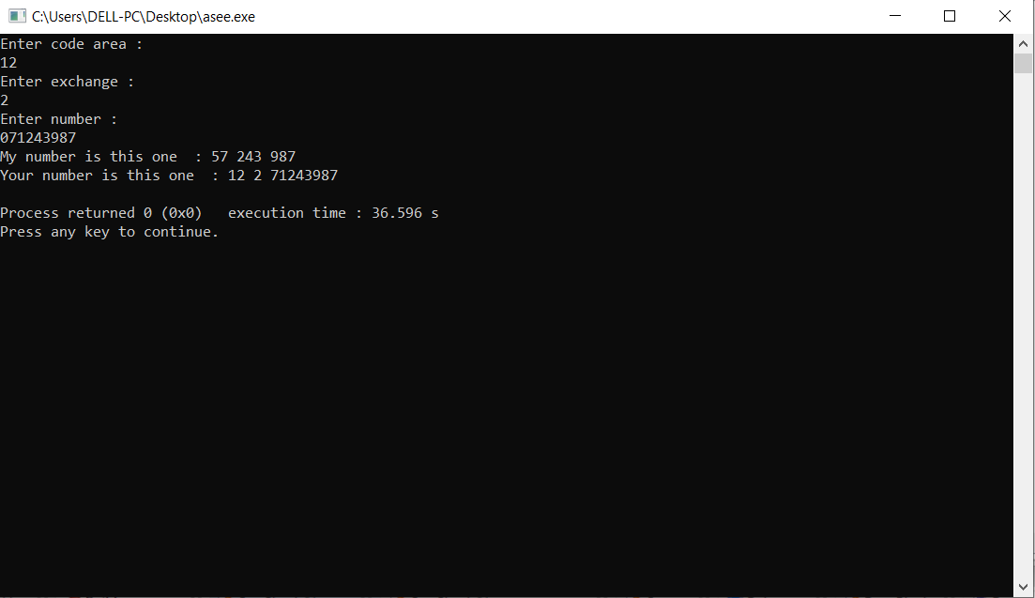

**2. Write a C++ Program where you create a movie database using structures. i.e the struct**

**must have two members “title” and “year”. For test run add 3 movies into the database**

**and then display the move title and names.**

**Code :-**

#include<iostream>

using namespace std;

struct movies{

string title ;

int year;

};

main(){

movies x[3];

for (int i=0; i<3; i++){

cout<<"Enter movie name :"<<endl;

cin>>x[i].title;

cout<<" Enter the year of the movie :"<<endl;

cin>>x[i].year;

cout<<"\n\n";

}

for (int i=0 ; i<3; i++)

{

cout<<"the name of the movie is "<<x[i].title<<endl;

cout<<"the year of the movie is "<<x[i].year<<endl;

}

}

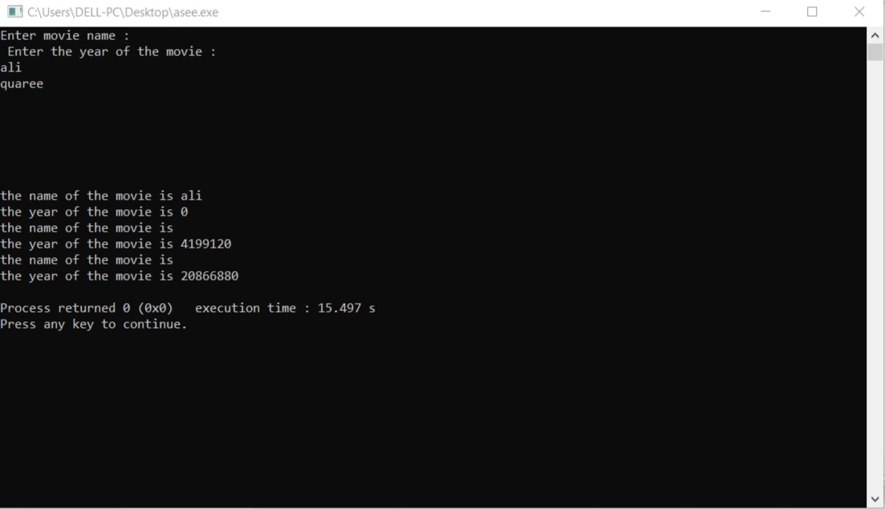

**3. A point on a two dimensional space has two numbers: an ‘X’ coordinate and a ‘Y’**

**coordinate such as (4, 5). Write a program that uses a structure called ‘point’ to model a**

**point and draw a rectangle of ‘*’ based on the entered height and width of the rectangle.**

**Sample Run:**

**Enter the point coordinates: (x, y)**

**3 2**

**Enter width of the rectangle: 3**

**Enter Height of the rectangle: 2**

**\* * \***

**\* * \***

**Code :-**

#include<iostream>

using namespace std;

struct point{

int height ;

int width;

};

main (){

point x;

cout<<"Enter width of rectangle :"<<endl;

cin>>x.width;

cout<<"Enter height of rectangle :"<<endl;

cin>>x.height;

cout<<"\nThe width of rectangle is :"<<x.width<<endl;

cout<<"The height of rectangle is :"<<x.height<<endl;

cout<<"\nRectangle is ....\n"<<endl;

for (int i=1; i<=x.height; i++)

{

for (int i=1; i<=x.width; i++){

cout<<" * ";

}

cout<<endl;

}

}

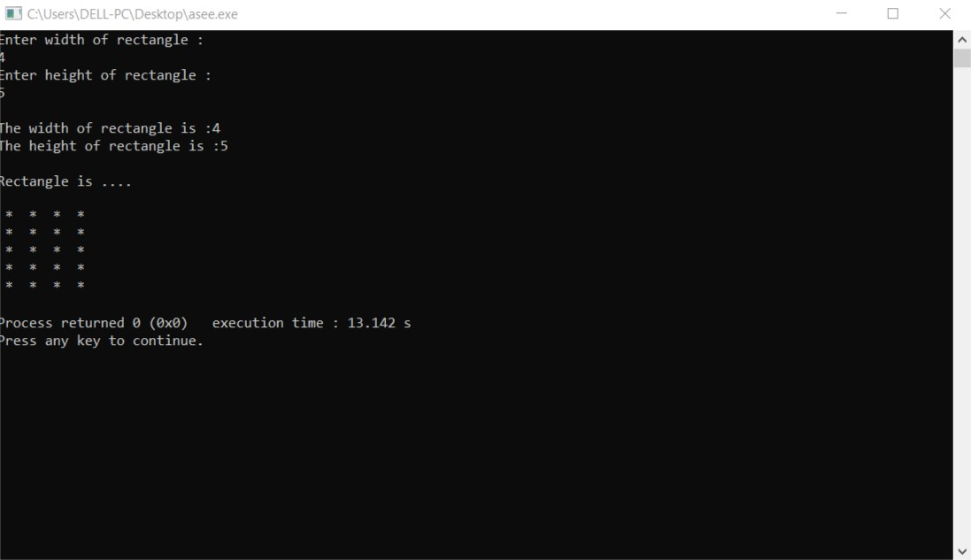

**4. Write a program to develop student information system. This system should be able to**

**take the student’s credentials, like name, reg no and semester no, as input and store them**

**in a structure object Student_t. The system should be capable of storing the information**

**of multiple students.**

**And it should be capable of displaying the student’s information, when asked to do so, via reg no.**

**Code :-**

#include<iostream>

using namespace std;

struct student{

string name;

string Regno ;

int semester;

string dept;

};

main(){

student x[4];

for (int i=0; i<4; i++){

cout<<"Enter name of the student:"<<endl;

cin>>x[i].name;

cout<<" Enter the registration number of the student :"<<endl;

cin>>x[i].Regno;

cout<<"Enter student's semeter number :"<<endl;

cin>>x[i].semester;

cout<<"Enter student's department name :"<<endl;

cin>>x[i].dept;

cout<<"\n\n";

}

string y;

cout<<"which student information you want ,Enter his reg.no :\n ";

cin>>y;

if (y==x[0].Regno){

cout<<"Name = "<<x[0].name<<endl;

cout<<"Semester no = "<<x[0].semester<<endl;

cout<<"Department = "<<x[0].dept<<endl;

}

else if (y==x[1].Regno){

cout<<"Name = "<<x[1].name<<endl;

cout<<"Semester no = "<<x[1].semester<<endl;

cout<<"Department = "<<x[1].dept<<endl;

}

else if (y==x[2].Regno){

cout<<"Name = "<<x[2].name<<endl;

cout<<"Semester no = "<<x[2].semester<<endl;

cout<<"Department = "<<x[2].dept<<endl;

}

else if (y==x[3].Regno){

cout<<"Name = "<<x[3].name<<endl;

cout<<"Semester no = "<<x[3].semester<<endl;

cout<<"Department = "<<x[3].dept<<endl;

}

else {

cout<<"No record found";

}

}

